**Road Safety Week 2023: Embracing Data Science to Save Lives on the Road**

**From Numbers to Solutions: Unravelling Road Safety Challenges with EDA**

In the ever-evolving landscape of road safety, understanding the intricacies behind accidents and collisions is paramount for crafting effective solutions. "From Numbers to Solutions: Unraveling Road Safety Challenges with EDA" embarks on a journey through the data-driven realm of Exploratory Data Analysis (EDA) to decode the patterns and insights hidden within the numbers. As we delve into the extensive dataset from 2022 collisions, this exploration aims to not only dissect the statistical landscape but also to pave the way for actionable strategies and solutions. Join us on this analytical expedition as we navigate through the intricacies of road safety, translating raw data into informed decisions for safer streets and a more secure future.

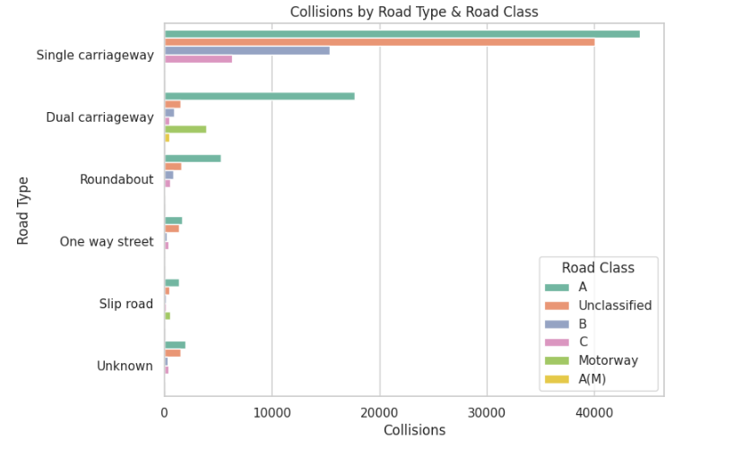

What we observe here is the Single Carriage is the place more number of collisions take place, and especially when it is 30 road and a “A” road.

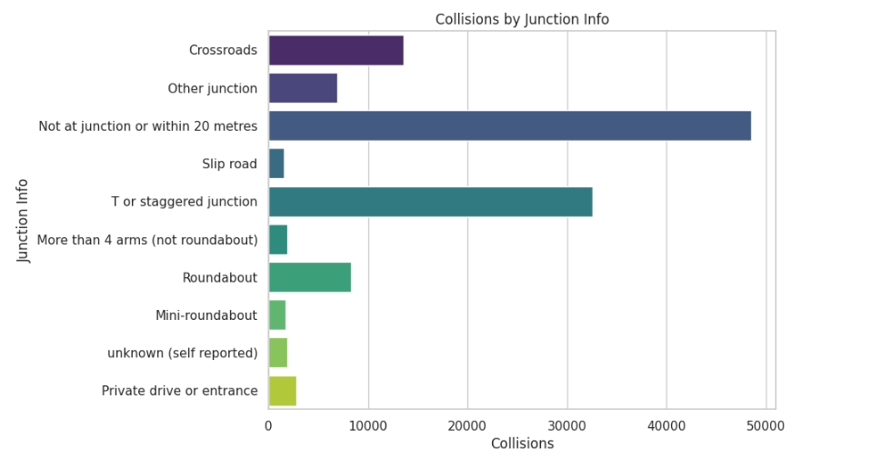

The above chart shows at what places in the road the collisions happened.

1. Most of the collisions are no where near to the junction, means may be because of speeding, sudden braking, pedestrian crossing the road in un-expected places. So while we drive in 30 roads, where we have footpaths, we should anticipate pedestrians crossing anytime, and always remember the rule “Tyres on tarmac”.
2. The second highest collisions happen in T junctions. In T or staggered junction, always pause for a while before you alight, and make sure there are no cyclist on your far side.

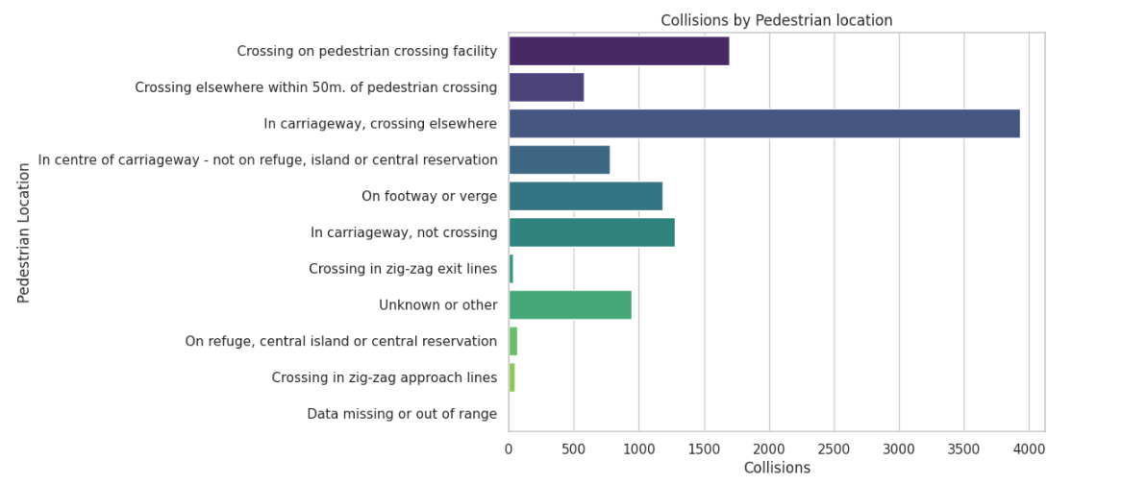

When a pedestrian is involved in the collision,

1. most of the times it is the pedestrian jumping into the road to cross to the other side. So cross the road only in pedestrian crossing and not anywhere else.
2. The second highest being the “Crossing on pedestrian crossing facility”. So make sure the vehicle has stopped completely before you step on to the pedestrian crossing, and don’t jump anticipating the vehicles will stop on flashing yellow lights.

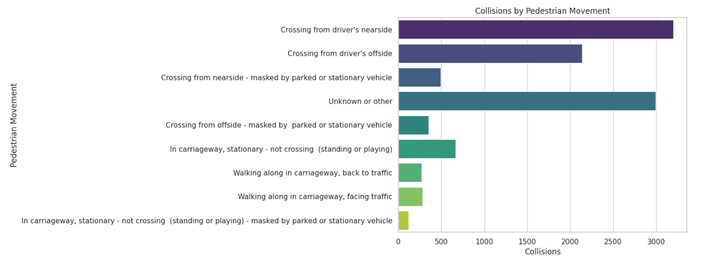

Cycles

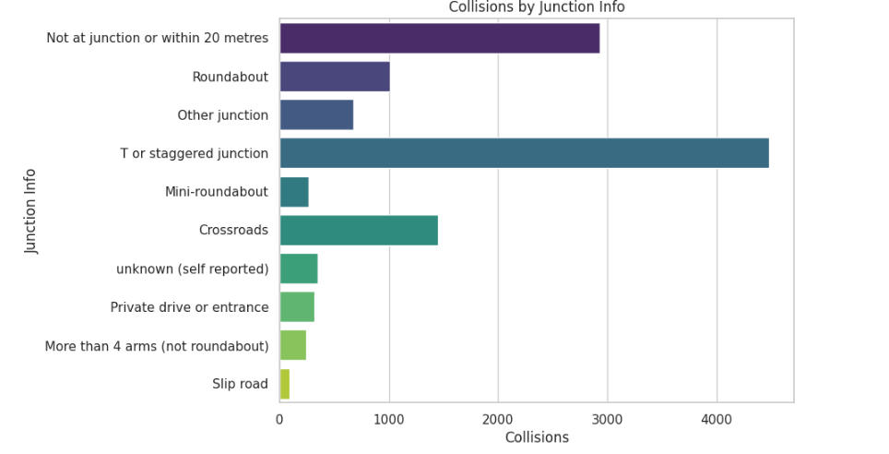

When it comes to cycles it is obviously in junctions where other driver misses to observe cyclists.

1. So while alighting from T junction, have a look on your near side and far side for any cyclists who may have arrived after you.
2. Also while overtaking the cyclists, make sure you leave at least 2 metres gap, so that they wont loose their balance due to wind pressure.
3. In round abouts, its hard to notice a cyclist, however it is always wise to look on both sides to make sure, cyclists have not approached.